PROJECT

DBMS

Submitted to:

Sehrish Khan

Submitted by:

SHANZAY MAHMOOD

Neelam Shahzadi

ROLL_NO:

110852 & 110828

**Department of InformatIon technology UnIversIty of the punjab lahore, pakIstan**

**CONTENTS:**

*COMMANDS:*

* *CREATE*
* *DESCRIBE*
* *INSERT INTO*
* *UPDATE*
* *AS*
* *DSITINCT*
* *ORDER BY*
* *WHERE clause*
* *SELECT COMMAND*
* *ARITHMETIC OPERATORS*
* *RELATIONAL OPERATORS*
* *LOGICAL OPERATORS*
* *AND BETWEEN*
* *IN*
* *LIKE*
* *NULL and NOT NULL*
* *AGGREGATE FUNCTIONS*
* *GROUP BY*
* *HAVING*
* **IMPLEMENTATIONS OF DIFFERENT COMMANDS ON MYSQL ;**
* DENTAL_CLINIC DATABASE:

First of all create database which you want to made as per according to your desire by using the syntax.

***Syntax:***

**CREATE DATABASE database_name;**

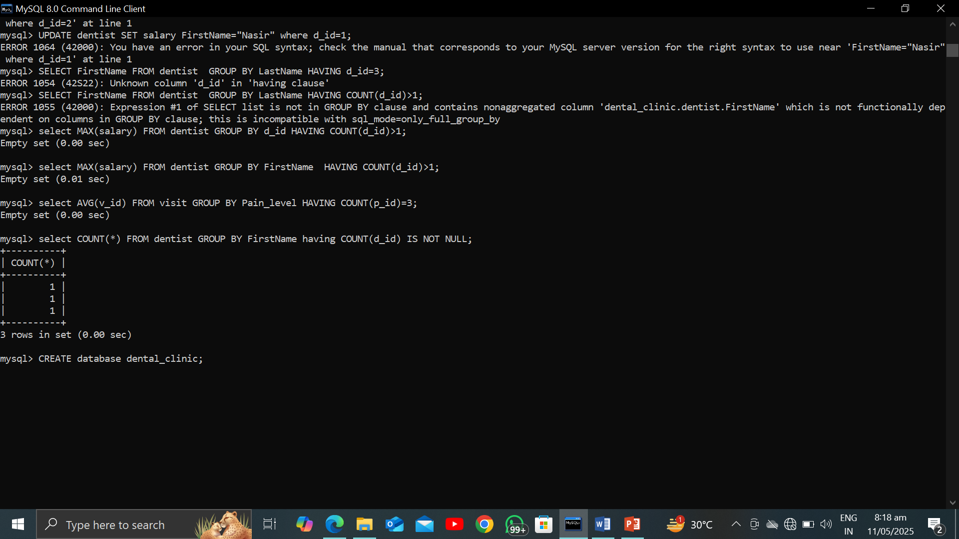

* Use your already made database as by use the words as;

***Syntax:***

**USE database_name:**

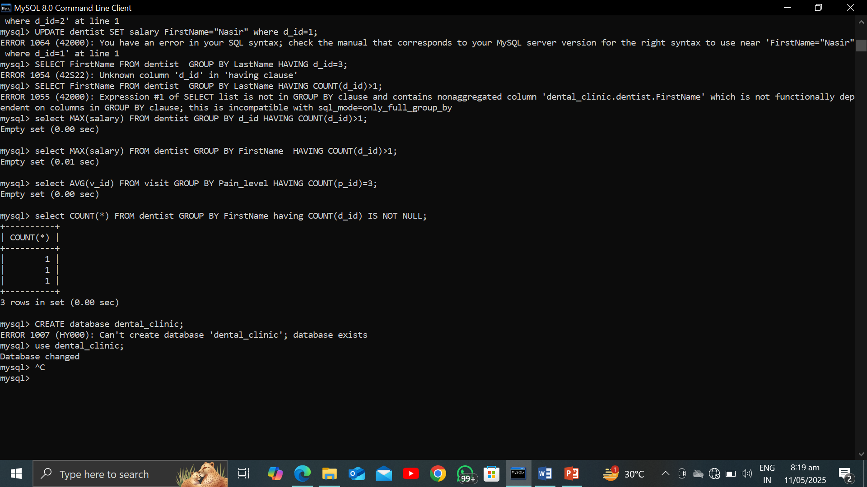

* CREATE command:

It’s used for the creation of tables.

Evolving the following statement;

***Syntax:***

**CREATE TABLE table_name(column_1,column_2…..);**

***Example:***

***Patient Table:***

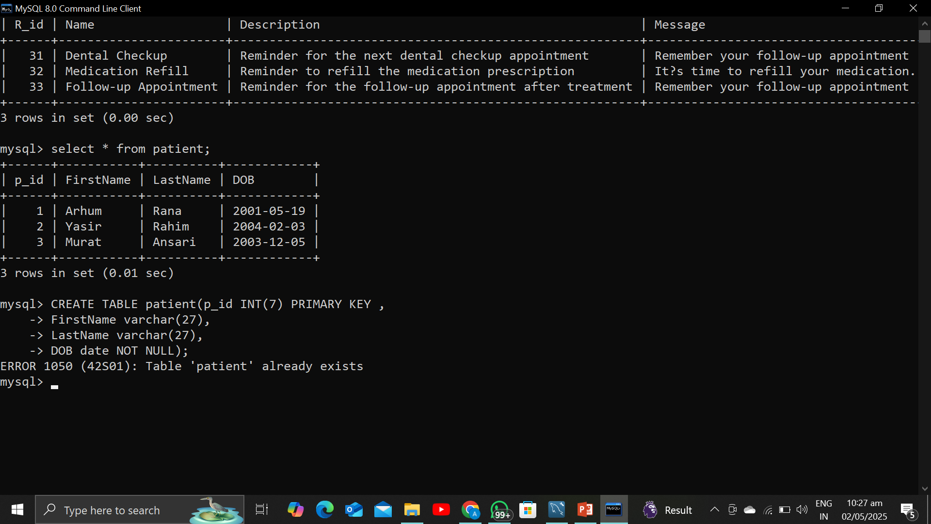

***Dentist Table;***

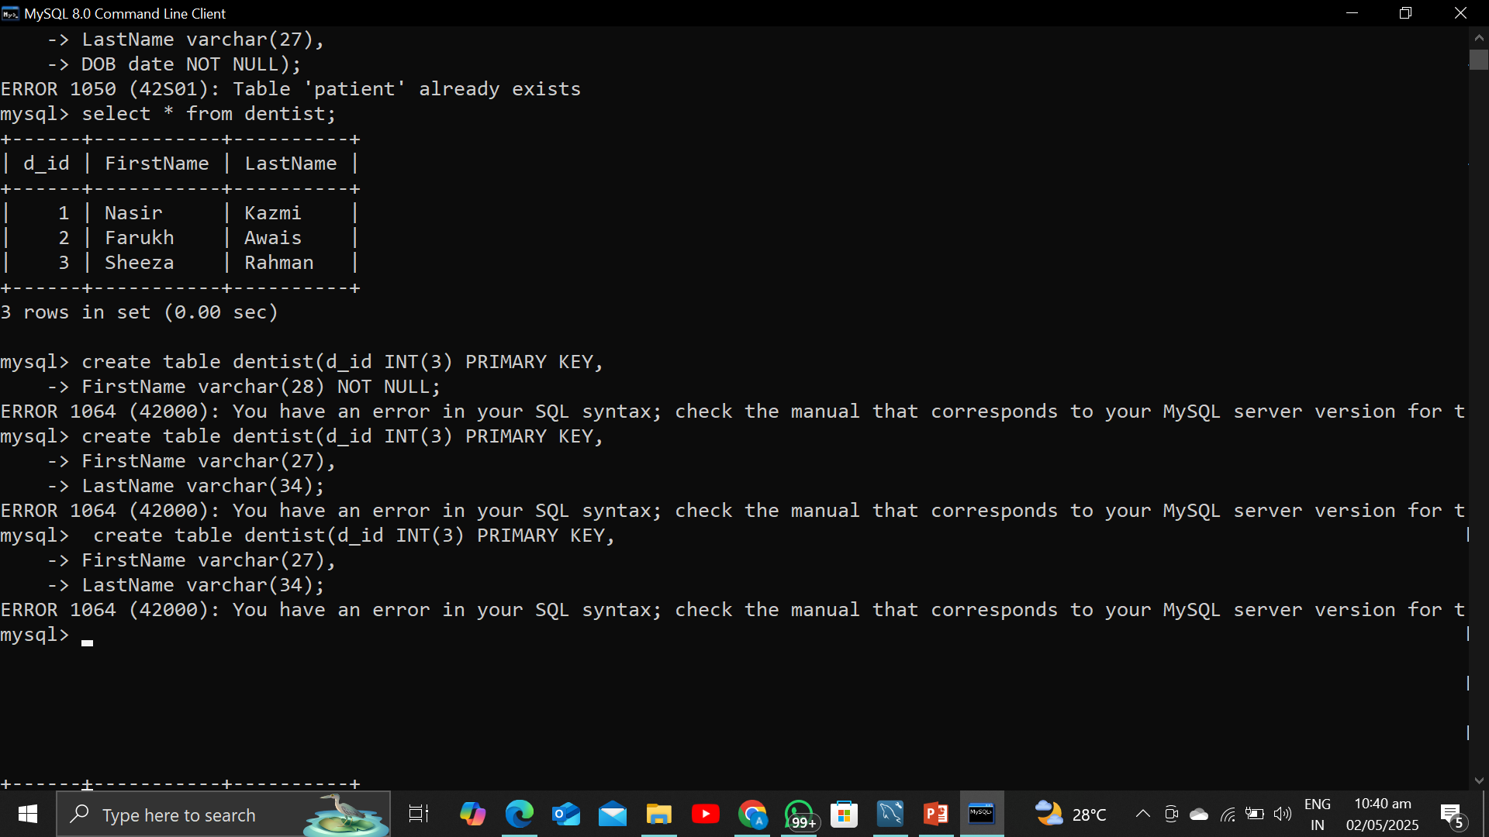

Use of DESCRIBE COMMAND:

It’s also can be used as the **DESC** shortly.

***Syntax:***

**DESC Table_name;**

**Examples:**

***VISIT TABLE:***

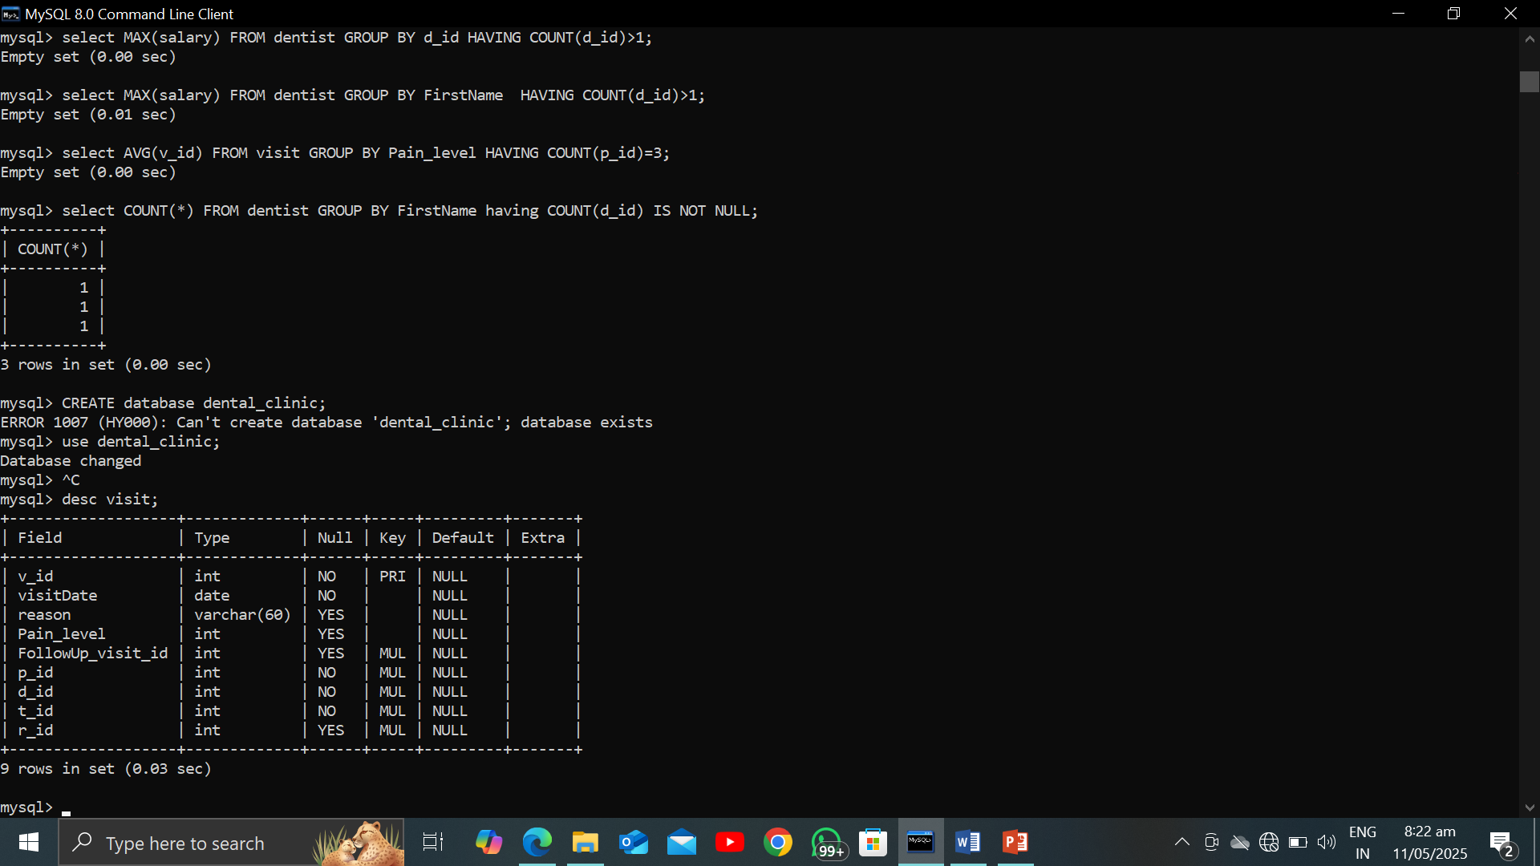

* INSERT COMMAD:

***Syntax:***

**INSERT INTO table_name VALUES (column_1’s Values,c_2,…….);**

**Example:**

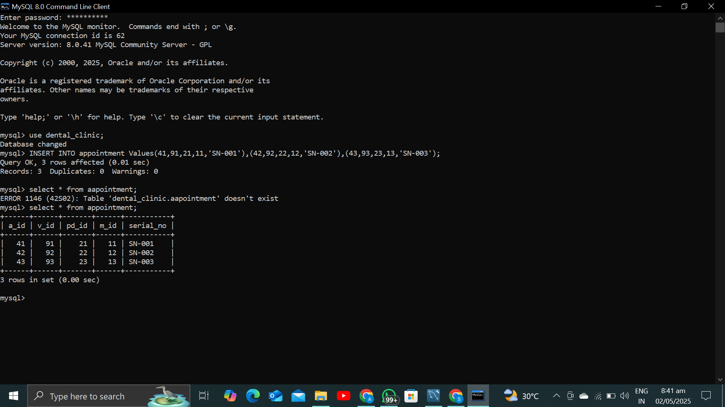

* SELECT * command:

This command is used for the displaying all and every single attribute’s **values** on the command prompt.

***Syntax:***

**SELECT * FROM table_name;**

***Example:***

***VISIT table:***

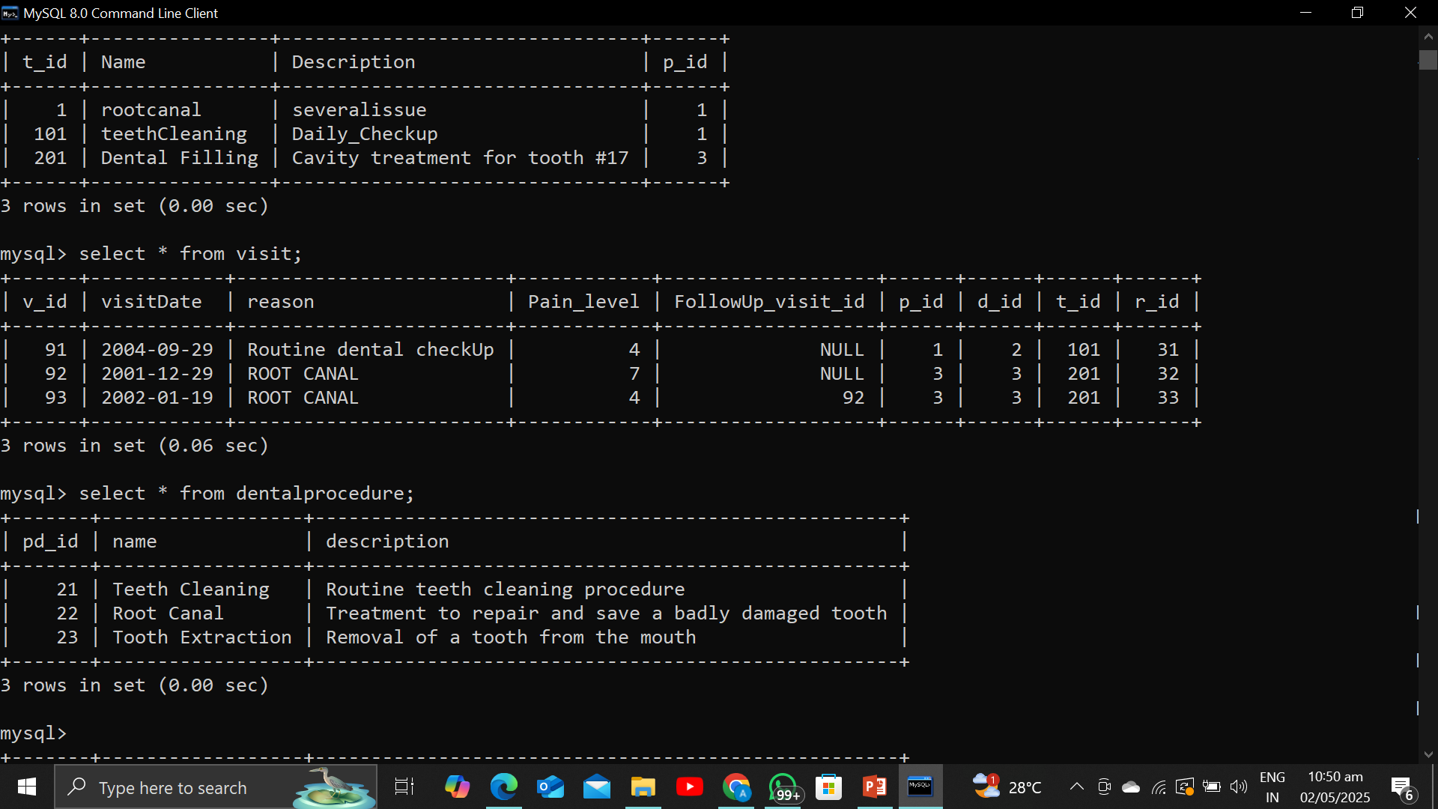

* *SELECT one/multiple column :*

This command is beneficial at that support while you are dealing with to come out the single one and the multiple attributes from a table rather then all of the attributes. Only a **certain** or **specific** values will be come out by this.

***Syntax;***

**SELECT column_name FROM table_name;**

***Example:***

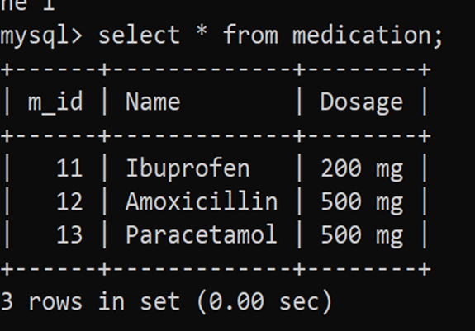

* ALTER command:

Used to alter the table and including other attributes or **inserts** more data into the table.

***Syntax:***

***ALTER TABLE table_name ADD column_name constraint;***

***Example:***

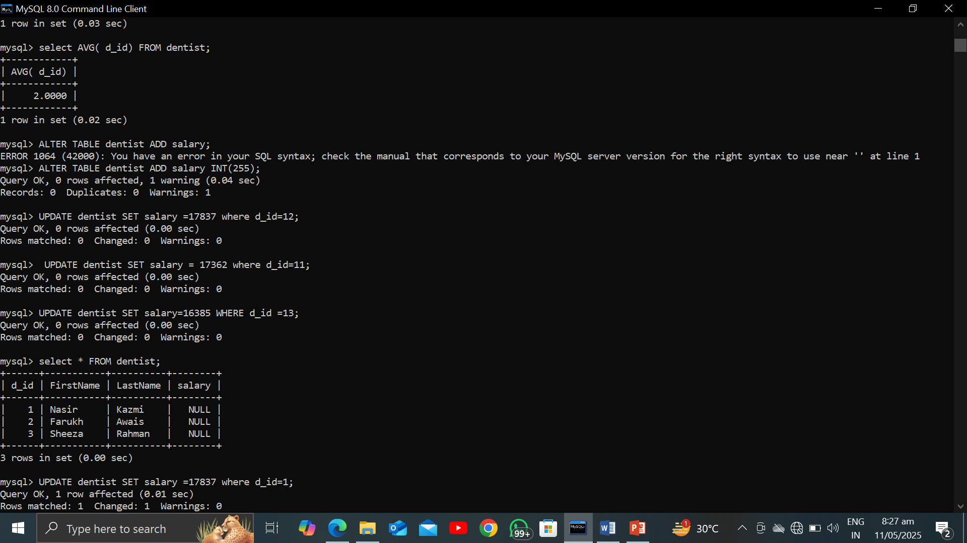

* *AS COMMAND on MySQL;*

This is basically used to make an alias of the attribute. It’s helpful where you want to access the already attribute name with the new one as you want.

***Syntax:***

**SELECT column_name AS alias FROM table_name;**



* *DISTINCT COMMAND:*

This command is used for duplicacy removal from your table if exist.

***Syntax:***

**SELECT DISTINCT column_name FROM table_name;**

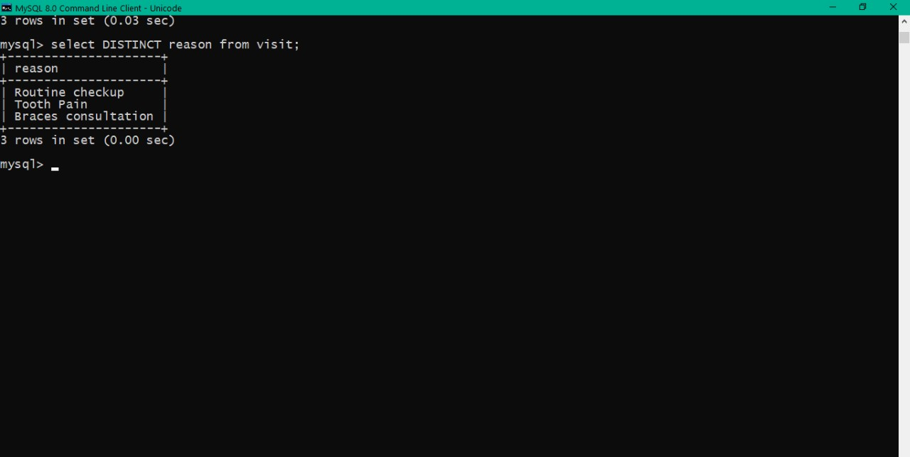

* WHERE clause in SQL:

Where command is work as such like fro the condition .

***Syntax:***

**SELECT * FROM table_name WHERE column=”value”;**

***Example***:

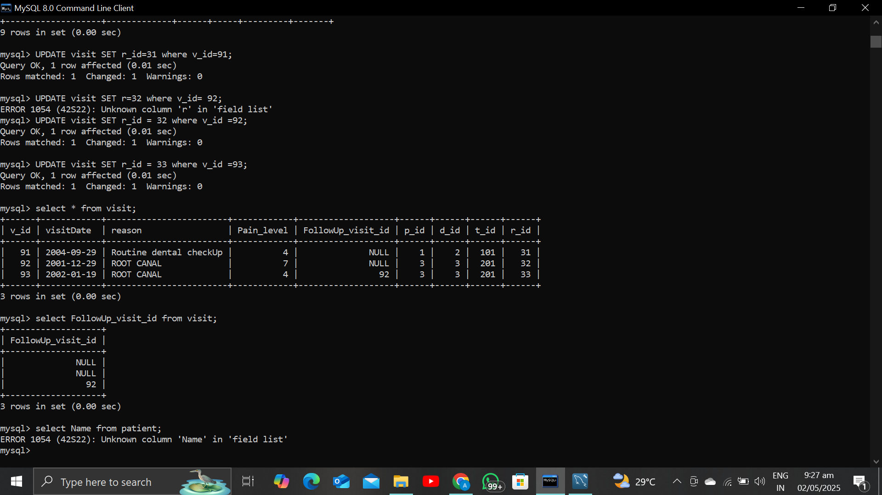

* *ORDER BY command:*

It’s used for the ascending or descending order sorting. By default ascending sort is done by the complier.

***Syntax;***

**SELECT column_name FROM table_name ORDER BY column_2 DESC;**

***Example:***

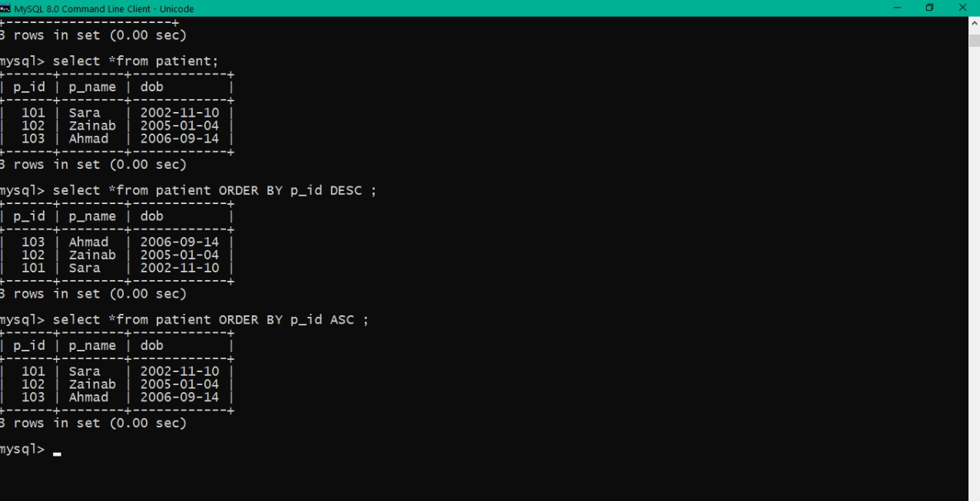

* ***OPERATORS IN SQL:***Arithmetic operators including (**+,-,*,/**).

***Syntax:***

***SELECT column_name OPERATOR FROM table_name WHERE column_name=”Values”;***

Or

**SELECT column_name FROM table column_name OPERATOR anyOperation;**

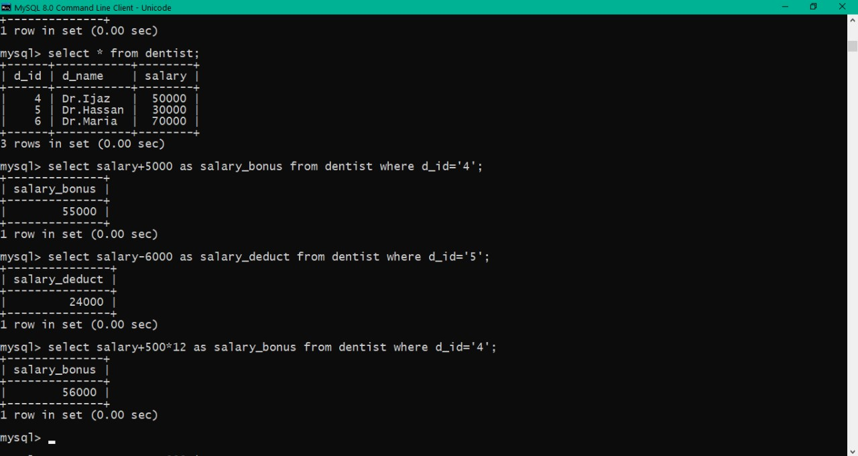

* **Relational operators:**

These operators including **(>,< ,>=,<=,==,!=)**

***Syntax:***

**SELECT column_name OPERATOR from table_name WHERE column_name=”Values”;**

Or

**SELECT column_name FROM table_name WHERE column OPERATOR condition;**

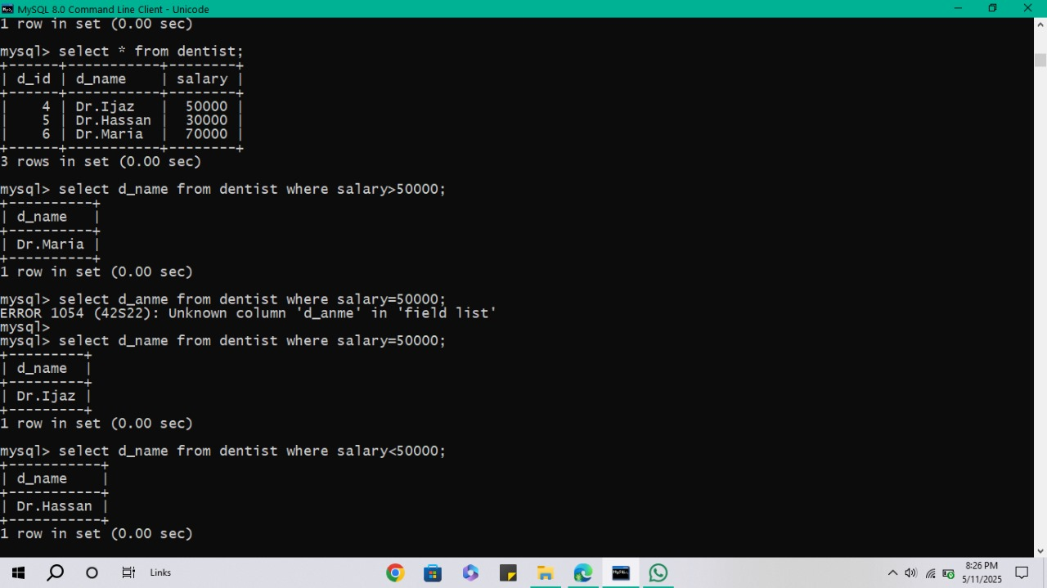

* ***Logical Operators:***

AND ,OR ,NOT.

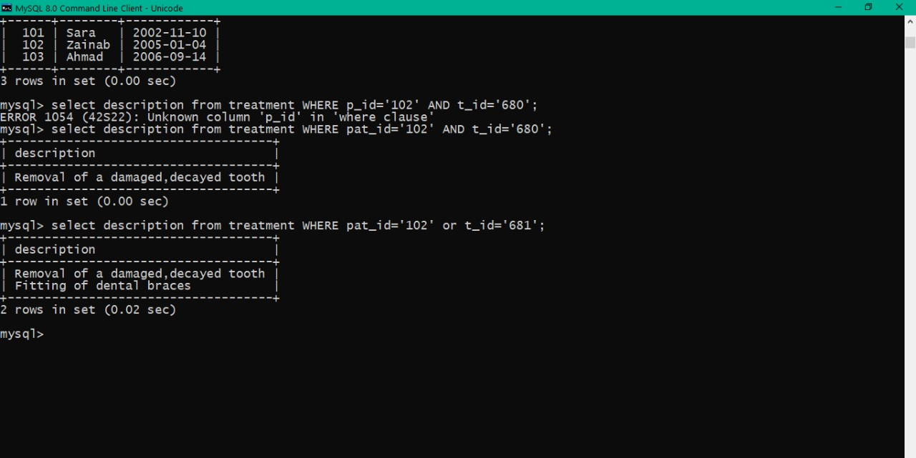

* ***SQL QUERIES BY AND,OR OPERATOR;***

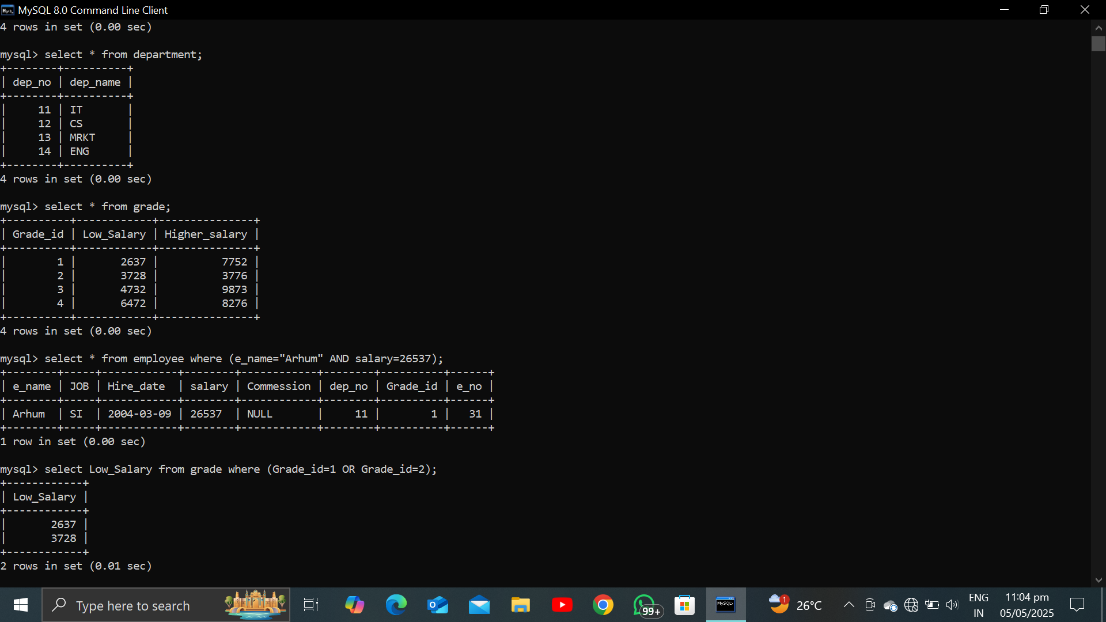

* USE OF MULTIPLE AND OPERATOR:

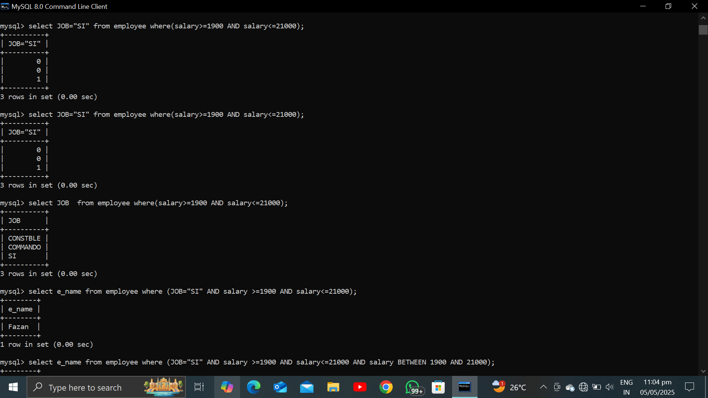

* AND BETWEEN:

It’s used where you want to evaluate the values from the range.Within that specific range.

***Syntax:***

***Select * FROM table_name where( cond_1 And Cond_2 Between Cond_3);***

As you can use any column_name rather then the asterisk inside the query.

***Example:***

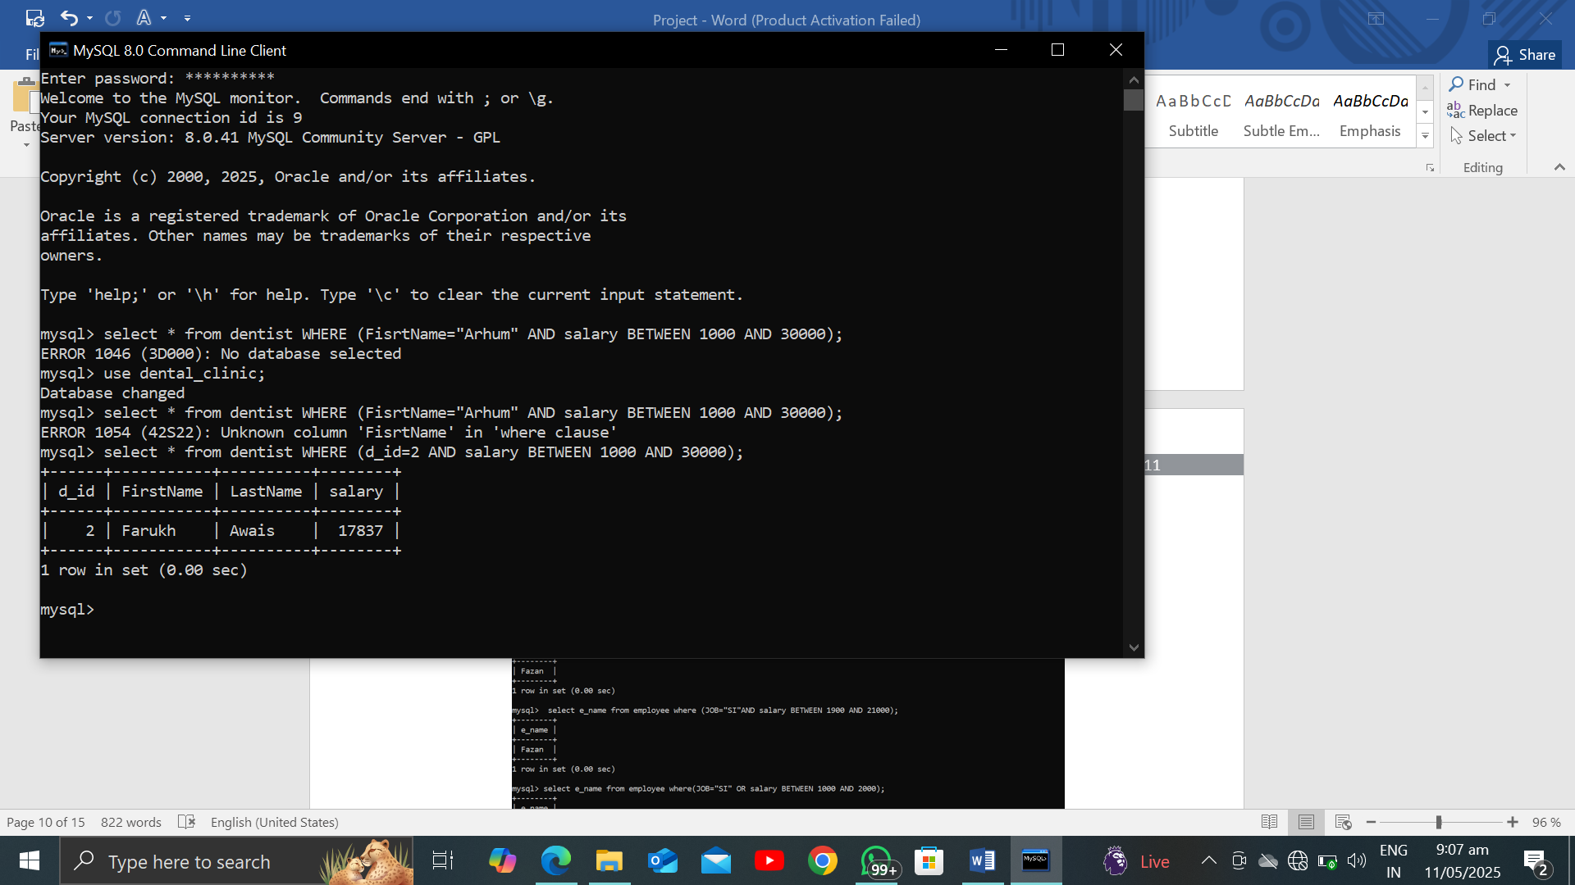

* OR BETWEEN is same as that of the AND BETWEEN.
* IN COMMAND:

It’s use to come out the certain value from the list of the table. It’s basically used to reduce length which is taken by multiple AND or OR operators.

***Syntax:***

**Select column_name from table_name where column_name IN(v_1,V_2);**

***Examples:***

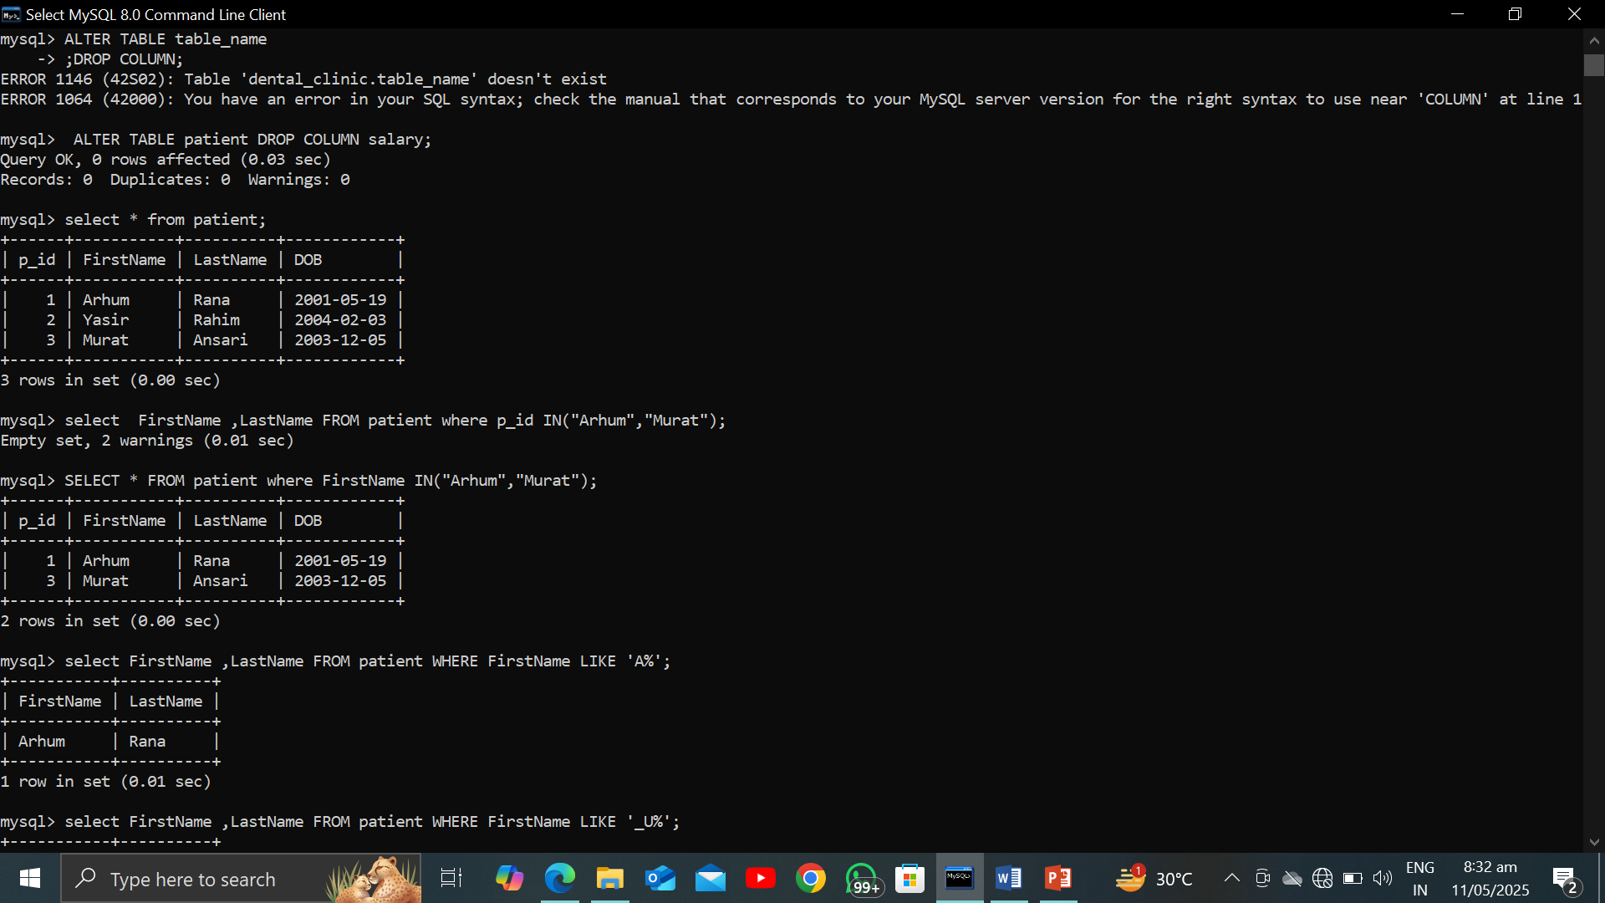

* *LIKE COMMAND:*

As if you want to evaluate a specific personality from a table whose spelling you are specifying in the query or any other name whose end or start or at any middle element you’ll be mentioned by you. This command is beneficial at that spot while you want to take a name whose character you’ll not be known is advanced.

* ***Wildcard Characters;***
* **%**( Represents the single ,null or multiple characters)
* **_**( Represents a single character)

***Syntax: Select c_1,C_2 FROM table_name where c_name LIKE pattern;***

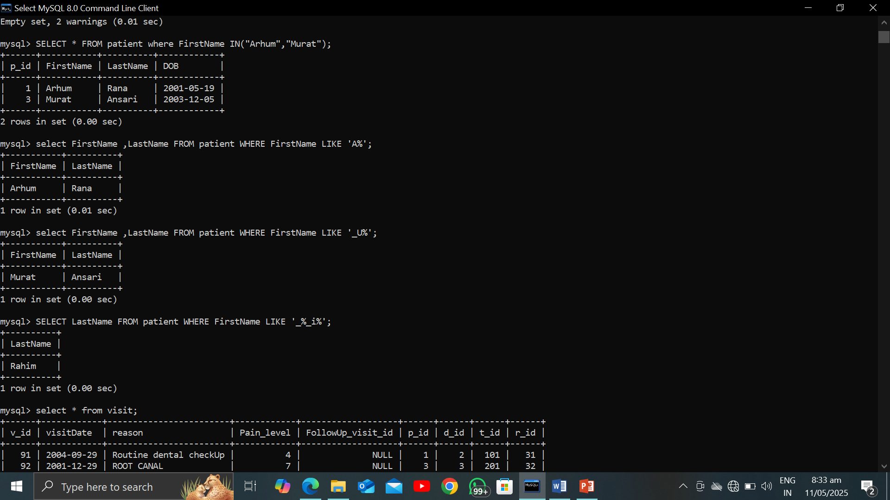

* *IS NULL OR IS NOT NULL:*

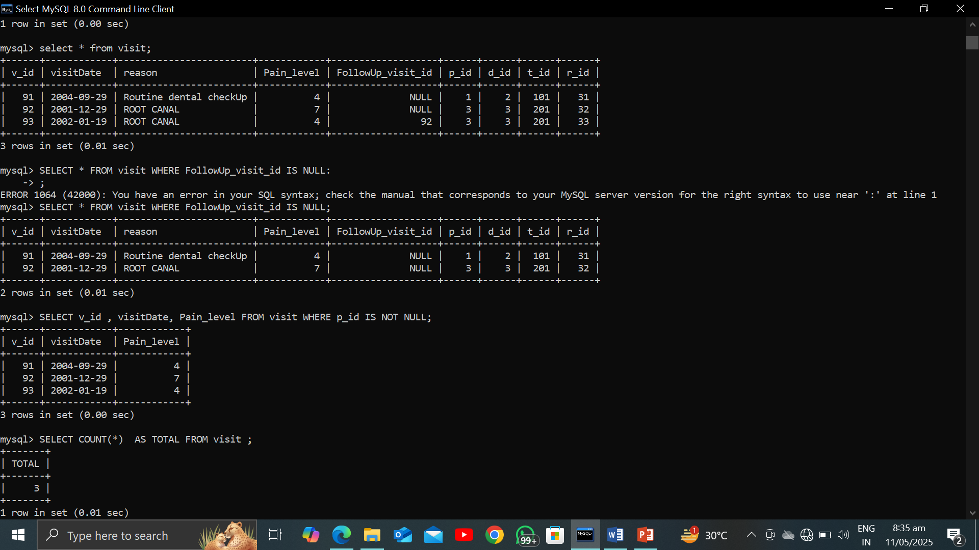

* AGGREGRATION FUNCTIONS:
* COUNT(column_name)
* Count(*)
* Avg(COLUMN_NAME)
* MAX(COLUMN_NAME)
* MIN(COLUMN_NAME)
* SUM(COUMN_NAME)
* ***COUNT COMMAND:***

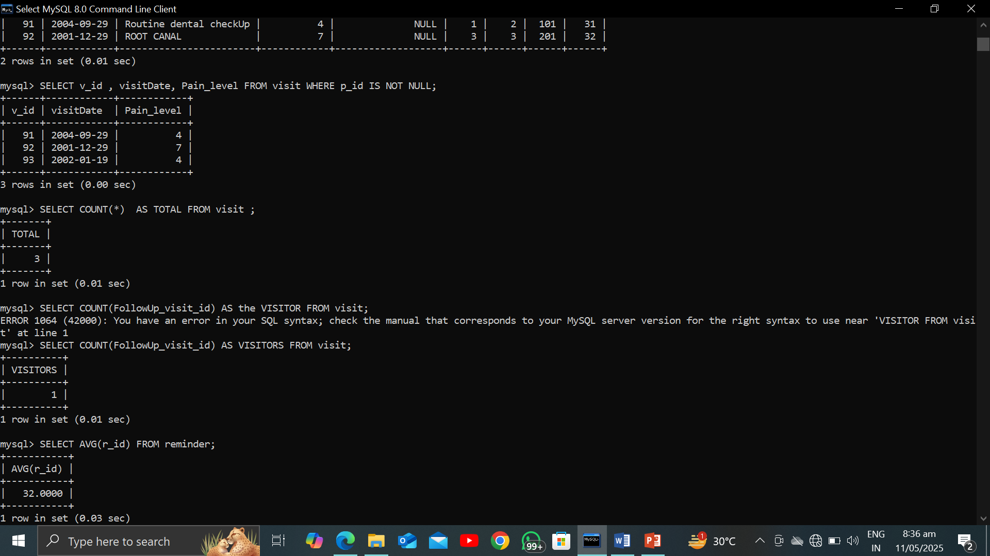

* **COUNT(*)** will display the all the colums which is include in your tables including the **null** values and also the **duplicate** values.
* **COUNT(column_name)** will display ONLY the **singly** values and not null vaues.
* *AVERAGE FUNCTIONS****:***

***Syntax:***

***select Avg(column_name) from table_name;***

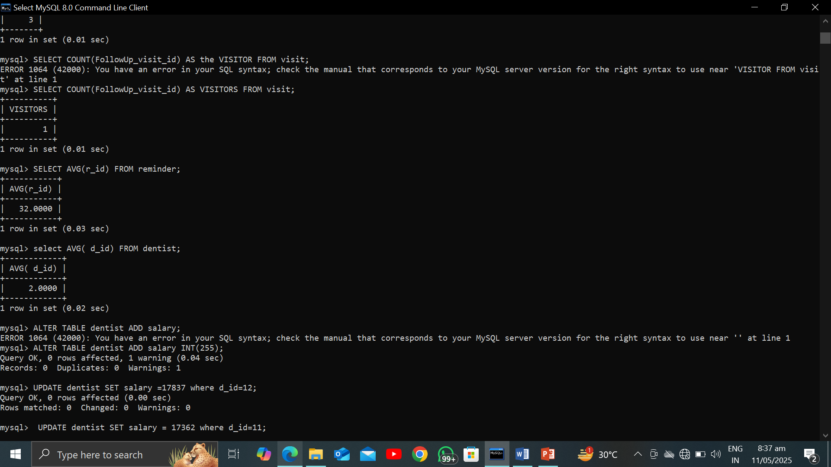

OTHERS functions:

Using Alter command to addup a column is dentist table named aas salary for the aggregate functions.

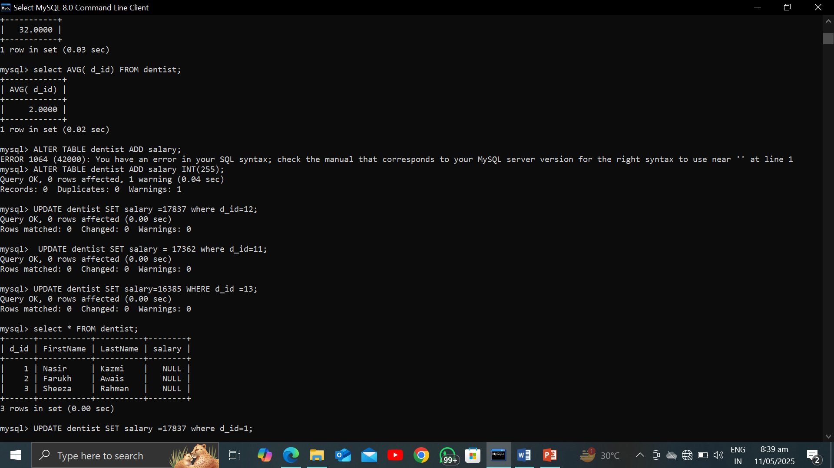

Now insert values in the salary table just for the sack of these functions.

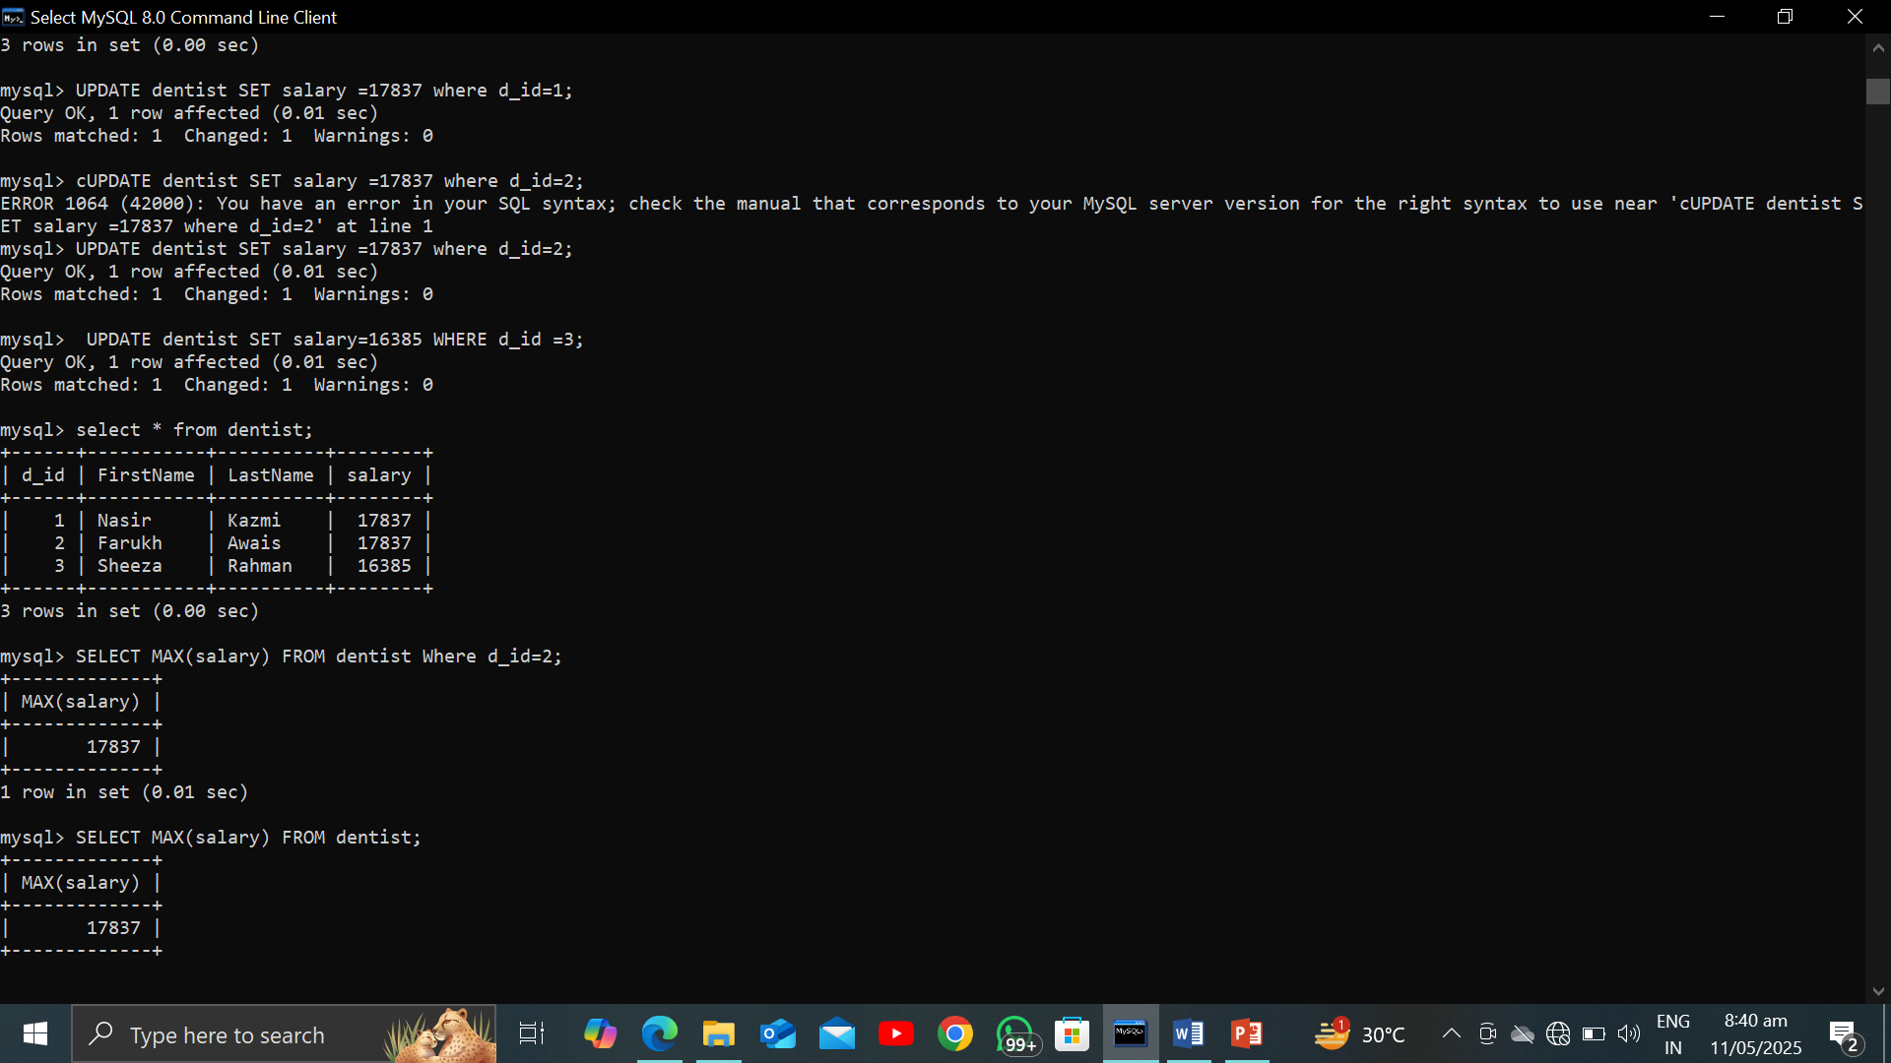

***OTHER functions:***

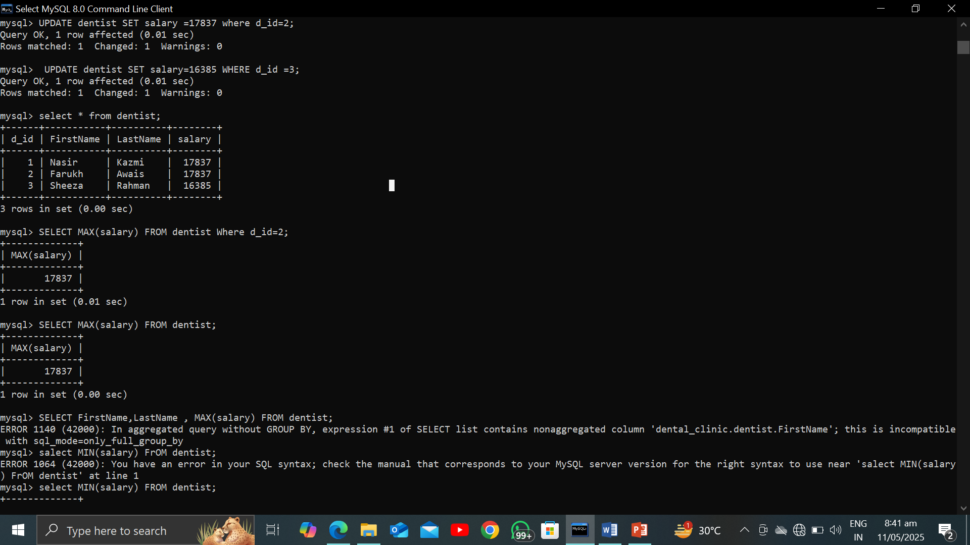

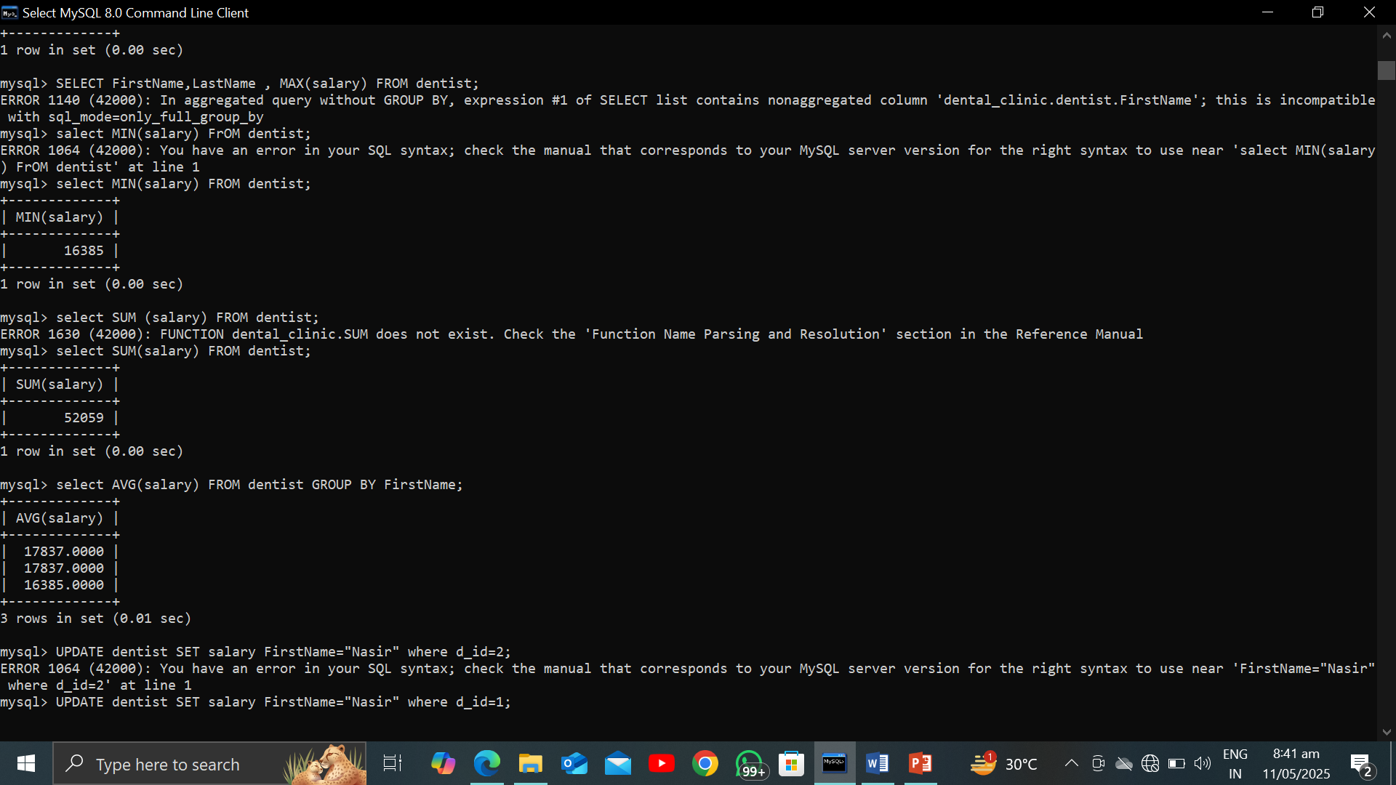

* GROUP BY :

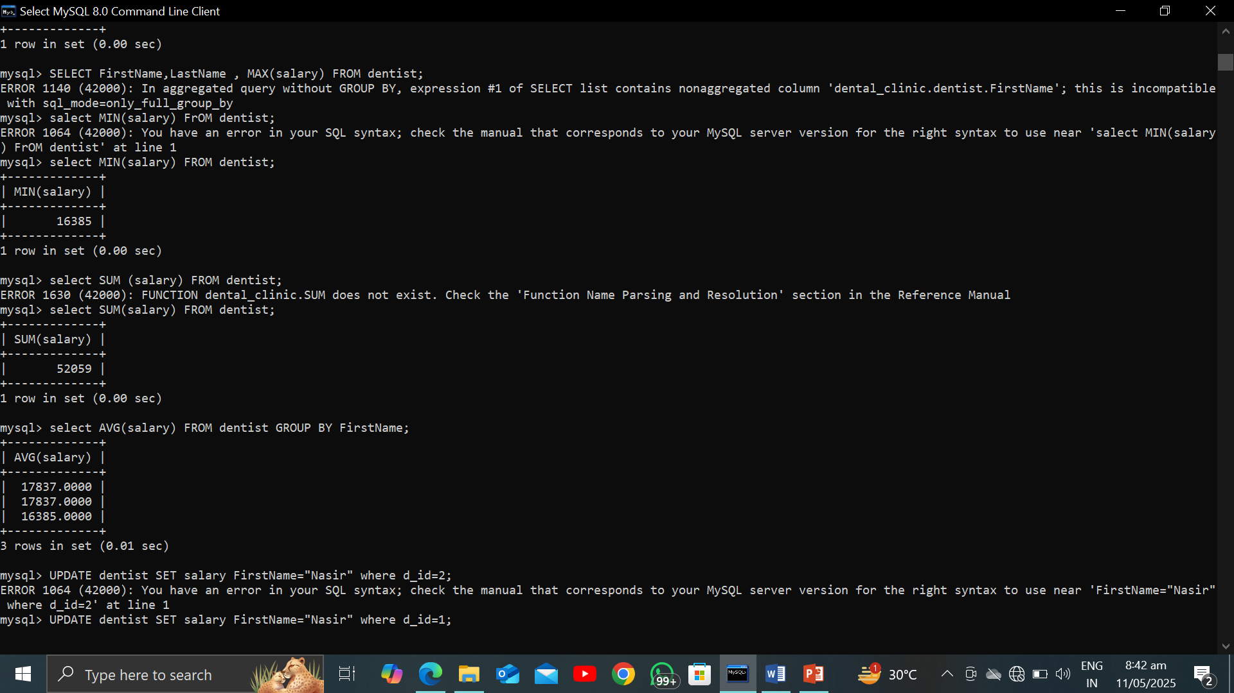

* HAVING COMMAND :

It’s use as such to apply the conditions indirectly which is not done with the help of where command as while you are dealing with the **GROUP BY** in sql. So for the sack of that purpose you have to use the HAVING to filter out of data or attributes as you want from the table.

* Practical Implementations:

